Images of our 2018 September Visit at Bear Spring Camps, Belgrade Lakes, Maine

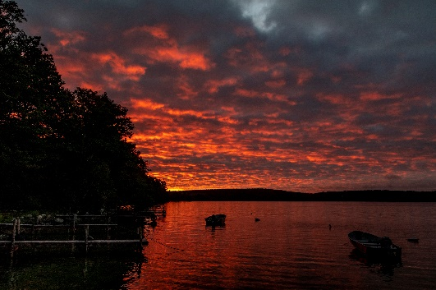This is a photo album of our Fall stay at Bear Spring Camps, Belgrade, Maine. Our September Fall holiday brought 13 days of excellent kayaking and several days of really nice swimming in clear waters. This album includes various photos of us kayaking and doing this and that while absorbing the wildlife and tranquality. Also included are photos of a day by the Rockport harbour.

Note that the wildlife from photos captured from our moving kayaks. The photo opportunities were often and excellent as was the dining room food and our accodomations.

And for the photos, click [Bear Spring Camps, ME, - September 2018.](https://photos.app.goo.gl/Rigitc4Tcf9vAJuM9) You are encouraged to “Zoom”.